Part B

**Title of Micro - project:** Micro – project to draw Data flow(DFD) and ER(ENTITY RELATIONSHIP) - diagram for Hospital Management System**.**

1. **Brief Description:**

* Data flow diagram represent the control flow the analysis model.
* ER- diagram represents the entity relationship.
* It is use to represent data flow model of analysis model.
* The data flow diagram is part of the structured analysis modelling tools.
* Data flow shows the transfer of information from one part of system to another.
* We have created Data flow Diagram of level 0, Level1for Hospital Management.
* In level 0 of Data flow Diagram the connecter Hospital Management System is connected to Employee Management, Patient management, System User Management, Login Management, Doctor Management, Hospital Management.
* In level 1 of Data flow Diagram the connector Hospital Management System is connected to Generate hospital reports, generate patient reports, Generate test reports, Check user login details, Test Management, Medicine management, Patient Management, Hospital management.

1. **Aim of Micro - project:**

* There are 6 various level of Data flow diagram all details of data gets covered in as use go from one level to another.
* Level 0 Data flow Diagram give the main system description.
* Level 1 Data flow Diagram give more details of Hospital Management system compare to level 0.
* Different tools are available to draw various level Data flow Diagram and ER-diagram.
* We have use Star UML Tool for drawing data flow diagram and ER-diagram.
* It is effective communication tools for designer.

1. **Course Outcome Integrated:**

* Use of Software Modelling to create a data design.
* Data flow Diagram and ER-diagram represent the analysis modelling concept.

1. **Actual Procedure Followed:**

* **Group Formation:**

SEN is subject which teaches us some important concepts that we should keep in while developing a software. The basic aim of micro- project is to accelerate the attainment of the various outcome in the course. In the first 2 weeks of January the subject was introduced. The syllabus as well as detail of micro-project was discussed. The group of 3members were formed and the group leaders were selected. The schedule of Plan “A”,” B” & “PRESENTATION” were finalized. The various micro-project topics related to subject was discussed our guide gave us the opportunity to select the topic of our choice.

* **Finalization of Micro-project:**

After attending the lectures for 2 weeks. We selected the topic for micro-project. We discussed the topic with our Guide regarding the concept which we are going to apply in the project. We individually tried to explain the basic platform of project.

* **Planning:**

After finalization of the project we started working on the project. We started the planning phase. We discussed among ourselves regarding the resources such as software requirements, Hardware requirement, etc this week we completed ‘PART A PLAN’ of the micro-project which is nothing but an initial description about the project. We submitted it to the guide.

* **Analysis Part :**

We started with the analysis of requirement. We gather all the information regarding the project. We created the rough model which is also called as proto-type model. We explained the proto-type model in front of guide. The guide suggested us some changes in the proto-type model. We later discussed the working of proto-type model in brief.

* **Designing Part** :

Here we started the technical level of development of our project. We implemented the requirements in the design part. We created an architectural design of the project which was finalized by the guide. We segregated the information available into units which helped to find redundant information.

* **Implementation :**

Each member of the group created their own part. Once we had the units ready, we stated making Data Flow diagram and Entity Relationship diagram as we knew about every levels of Data Flow diagram , we started designing it. Finally, we combined all the part & tested the output of the model whether it is according to the requirements.

* **Presentation :**

In this week we have to present the micro-project in front of the guide. Each member of group presented their own parts with confidence in front of guide. She asked us various queries regarding the topics. We presented the details of each concept of Software Engineering that we used in the project. She asked us to do various changes regarding some topics.

* **Submission :**

This week was submission week. We submitted our project along with ‘Part A & B Plan’ to the guide. We also submitted the hard copies and soft copies of project to the guide.

1. **Actual Resources Required :**

|  |  |  |  |  |
| --- | --- | --- | --- | --- |
| **Sr. no** | **Name of resources used** | **Specification** | **Quantity** | **Remark** |
| 1 | COMPUTER | **PROCESSOR-**AMD  **HARD DISK-**2 TB  **RAM**-16GB  **OPERATING SYSTEM-**WINDOWS 10 PRO | 1  1  1  1 | HARDWARE & SOFTWARE USED |
| 2 | Software  tools | Star uml |  | Software |

1. **Output of Micro -project :**

|  |  |
| --- | --- |
| **Sr no** | **Contents** |
| 1 | **Theory-** Data Flow Diagram |
| 2 | Level 0 Data flow Diagram |
| 3 | Level 1 Data flow Diagram |
| 4 | Advantages and Disadvantages of Data Flow Diagram |
| 5 | **Theory –** Entity Relationship Diagram |
| 6 | Entity Relationship diagram |
| 7 | Advantages and Disadvantages of Entity Relationship Diagram |

* **Data flow Diagram (DFD):**

A data flow diagram maps out the flow of information for any process or system.it uses defined symbol like rectangles, circles and arrows, plus short text labels to show data input, output, storage point and route between each destination. Data flowchart can range from simple, even hand drawn process overview to in depth multi – Level Data flow diagram that dig progressively into how data is handled. That’s why Data flow diagram remains so popular after all these years. As they work well for data flow software and systems. But they are less applicable now days due to

Visualizing interactive, real – time database-oriented software or systems.

* Level 0 of Data flow diagram is also called a Context Diagram. It’s basic overview of the whole system or the process being analysed or modelled. Its designed to be an “at a glance view “of the system showing as a single High-level process with its relationship to external entities.it should be understood by wide audience which includes Stake holder, Developers, Data analysts, etc.
* Level one of Data flow Diagram provides more detailed breakout pieces of context level diagram. You will highlight the main function carried out by the System as you breakdown the high-level context diagram into its sub processes
* **Advantages of Data flow Diagram :**
  + It aids in describing boundaries of the system.
  + It is beneficial for communicating existing system knowledge to user.
  + A straight forward Graphical technique which is easy to recognize.
* **Disadvantages of Data flow diagram :** 
  + It makes programmers little confusing concerning the system.
  + The Biggest drawback of Data flow diagram is that it simply takes a long time to create. the time is so long that the analyst may not receive support from management to complete it.
* **Entity relationship Diagram:**

Entity relationship diagram also known as

ERD/ ER – Diagram/ ER – Model is a type of structural diagram for use in database design.an ERD contains different symbols and connectors that visualize 2 important information.

ER diagram are a visual tool which is helpful to represent the ER model. It was proposed by Peter Chen in 1971 to create a uniform convention which can be used for relational database and network he aimed to use an ER model as conceptual modelling approach**.**

This model is based on 3 basic concepts:

1. Entities
2. Attributes
3. Relationships

1. **Entity:**

It can be a real-world thing either living or non-living or it can be easily Recognizable or non – recognizable.it is anything in the enterprise that is to be represented in our database**.**

1. **Attributes:**

It may be a physical thing or simply a fact about enterprise or event that happen in real world.

1. **Relationships:**

Relationship is nothing but an association among 2 or more entities.

* **Advantages of Entity relationship model:**
* Conceptually it is very simple because if we know relationship between entities and attributes then we can easily draw a ER – diagram.
* Better visual representation that is ER-model is a diagrammatic representation of any logical structure of database by seeing ER-diagram we can easily understand relation among entities and relationship.
* ER-model can be easily converted into another data model like hierarchical data model, Network data model, etc.
* **Disadvantages of ER-model**
* Limited constraint and specification
* Some information can be lost or hidden in ER-model.
* ER-model represent limited relationship as compared to another data like relational model, etc.

1. **References :**

We do have used a few references during the process of building our project. The references used are from Websites, Books etc.

The references used are:

**WEBSITES:**

* + 1. [www.programiz.com](http://www.programiz.com).
    2. [www.tutorialspoint.com](http://www.tutorialspoint.com).
    3. [www.quora.com](http://www.quora.com)

**REFERENCE BOOKS:**

1. Software Engineering A practitioner’s approach by Pressman, Roger S.
2. Software Engineering Concepts by Fairly Richard
3. Software Engineering principles and practices by Jain Deepak
4. **Skill developed/learning out of this micro project :**

First and foremost, we learnt to work as a team and share information. We learned some activities such as to set a vision, serving, inspiring, etc which were related to the project we learned to have good communication. we improved our planning skills

Level 0 Data Flow Diagram for Hospital Management System

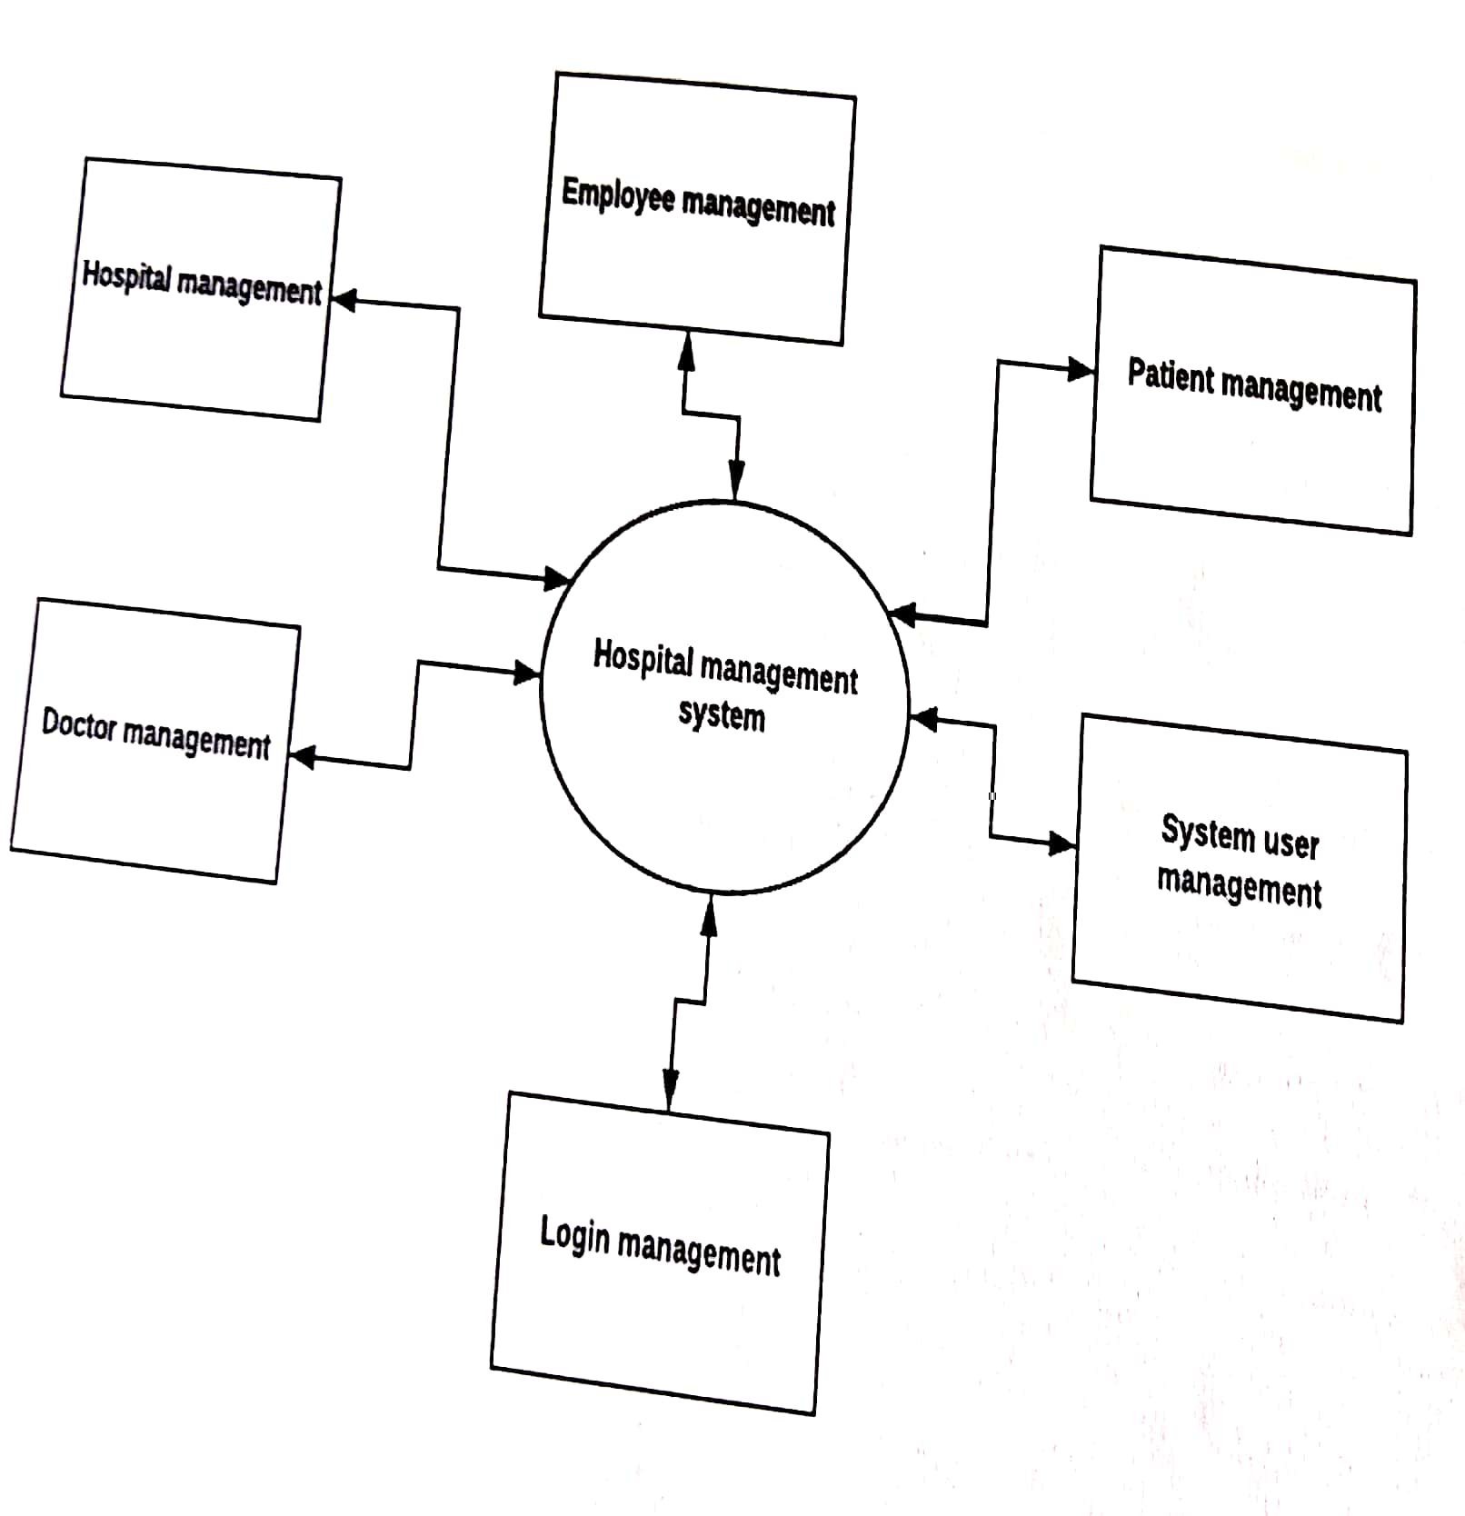

Level 1 Data Flow Diagram for Hospital Management System

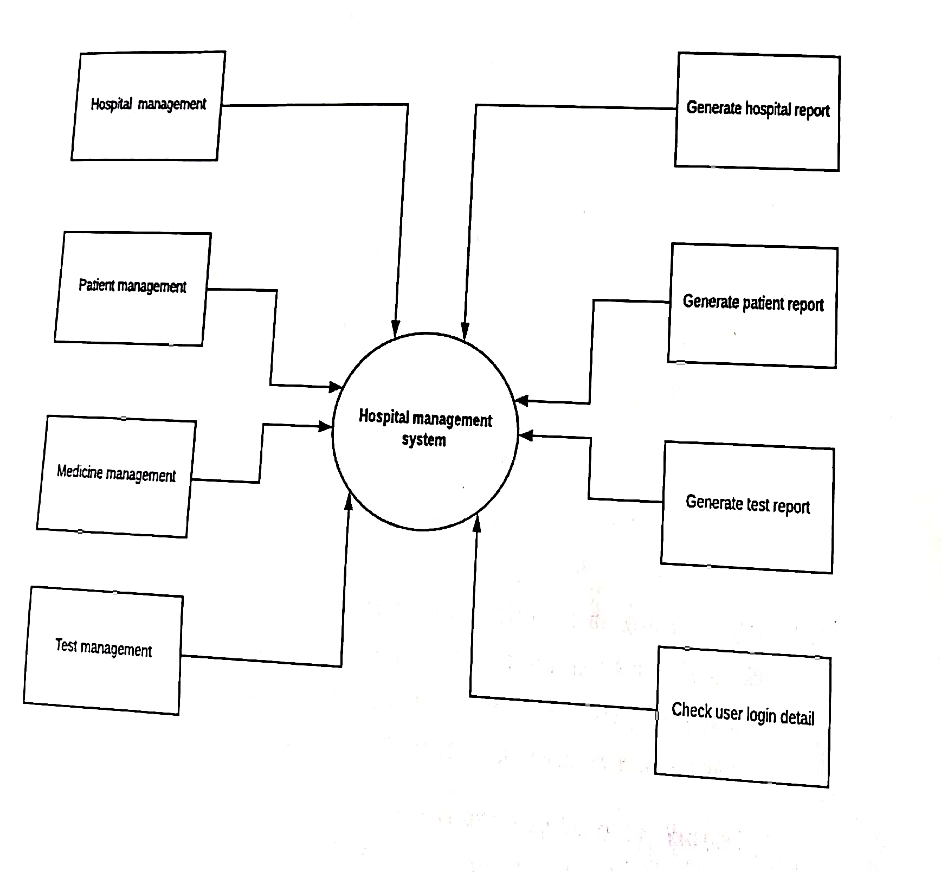

Entity Relationship Diagram for Hospital Management System

